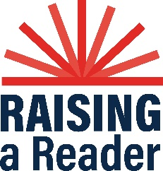
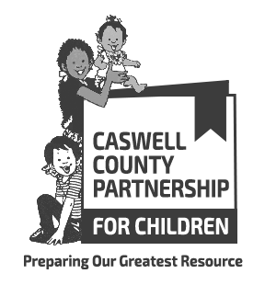

Caswell County Partnership for Children
Raising A Reader: Program Requirements FY 2023-2024

The Caswell County Partnership for Children (CCPFC) is accepting applications from early childhood education and literacy professionals to provide the Raising A Reader® (RAR) program for the 2023-2024 school year. RAR is an early literacy program designed to serve young children, from birth-Kindergarten, in environments where poverty, language barriers, limited formal education for parents, and other issues create challenges to regular book sharing. The program fosters family bonding moments and develops critical literacy and social emotional skills through shared reading. Every week during the school year, children bring home a Red Book Bag filled with high quality, multicultural books. The caring adults in their lives read with them regularly, creating shared reading routines. These efforts are supported by easy-to-use materials and training to help families effectively share books together with their children.

RAR Program Requirements:
To be eligible to serve as a RAR site, early childhood education and literacy professionals will be responsible for implementing the program with fidelity and meeting ALL of the following requirements:
- Work in a NC Division of Child Development and Early Education (DCDEE) regulated program, in a public school classroom or in an early literacy community site in Caswell County.
- Work with children between the ages of birth to 5 years.
- Serve some low-income children (includes children qualified for Head Start, NC Pre-K, and/or Subsidy Services).
- Attend two implementer trainings, one in Summer 2023 and one in Spring 2024. Participate in two site visits. These trainings and visits will provide educators with new strategies, support and relevant research. The initial training will provide the skills and early literacy materials educators need to successfully implement the program with a high degree of comfort and model fidelity. NC DCDEE contact hours may be provided for literacy content trainings.
- Provide at least two family activities with literacy content to develop parents’ book sharing skills; may be offered in conjunction with another activity or family friendly event. The first family activity must be provided before the book bag rotation may begin. Advertise and promote family events to ensure parent participation.
- Create and carefully manage a family friendly book bag rotation system. Teach children and families how to take care of the books. Book bag rotation should begin no later than the week of September 11, 2023, occur every week during the school year and continue through the week of May 13, 2024. Exceptions will be made for holidays and inclement weather; other exceptions require prior CCPFC approval.
- Provide weekly shared reading sessions using a RAR book. Shared reading sessions should begin no later than the week of September 11, 2023, occur every week during the school year and continue through the week of May 13, 2024. Exceptions will be made for holidays and inclement weather; other exceptions require prior CCPFC approval.
- Promote and participate in the annual library event that connects families with the local library, provides library card applications, and other community literacy resources.
- Administer parent surveys for every child participating in the program at the end of the year.
- Track book bag rotations, shared reading sessions, changes in enrollment, family activities and parent/caregiver participation, parent surveys and submit report by the 5th of month to help track progress and measure the impact of the program. Monitor condition of books and request replacements when needed.
- Include the following tag line and use the CCPFC and RAR logos, when possible, on program information and family invitations: Raising A Reader is brought to you by the Caswell County Partnership for Children through Smart Start funding.
- By 5 p.m. on Thursday, May 25, 2023, complete the online application at https://forms.gle/dgLdbdoAJeM8H1g87.

Questions regarding RAR or the application? Contact CCPFC Executive Director at 336-694-1538 or ccp4child@esinc.net.
PO Box 664, Yanceyville, NC 27379 - 336-694-1538 - fax: 336-694-7666
www.caswellchildren.org www.facebook.com/CaswellPartnershipForChildren

